Ideation Phase
Brainstorm & Idea Prioritization Template
Field | Details
Date | September 13 2026
Team ID
Project Name | Medical Diagnostic Center – ServiceNow Service Portal
Maximum Marks | 4 Marks

Step-1: Team Gathering, Collaboration and Select the Problem Statement
Problem Statement
Medical diagnostic centers often face challenges in managing patient appointments, diagnostic test bookings, payments, reports, notifications, and access permissions through a centralized system. Manual or disconnected processes can result in appointment conflicts, incorrect test pricing, delayed notifications, difficulty accessing reports, and data-security issues.
Selected Problem
To develop a centralized Medical Diagnostic Center application using ServiceNow that enables patients to browse diagnostic tests, book appointments, manage payments, receive notifications, and access reports while providing secure role-based access for staff and administrators.
Brainstorming Discussion
The team discussed possible solutions for improving the diagnostic-center workflow:
- Online diagnostic test catalog
- Patient appointment booking
- Appointment slot management
- Automatic test-price calculation
- Payment-status management
- Patient report management
- Email notifications
- Appointment approval workflow
- Role-based access control
- Service Portal for patients and staff
- Automated validation of appointment slots
Final Selected Idea
Medical Diagnostic Center Management System using ServiceNow

Step-2: Brainstorm, Idea Listing and Grouping
You can present the brainstorming ideas in these groups:
🏥 Patient Services
- Patient registration
- Diagnostic test catalog
- Online appointment booking
- Appointment cancellation
- View appointment status
- View laboratory reports
📅 Appointment Management
- Slot availability
- Duplicate booking prevention
- Overlapping appointment validation
- Appointment approval
- Scheduled-date validation
- Appointment status tracking
💳 Payment Management
- Automatic test-price population
- Payment status tracking
- Payment confirmation
- Refund management
📧 Communication
- Appointment confirmation email
- Approval/rejection notification
- Payment confirmation
- Report-ready notification
- Cancellation notification
🔐 Security & Administration
- Role-based access
- Patient data protection
- ACL configuration
- Admin management
- Staff access control
- Secure report access
⚙️ Automation
- Flow Designer workflows
- Business Rules
- Automatic data population
- Automated notifications
- Real-time slot validation
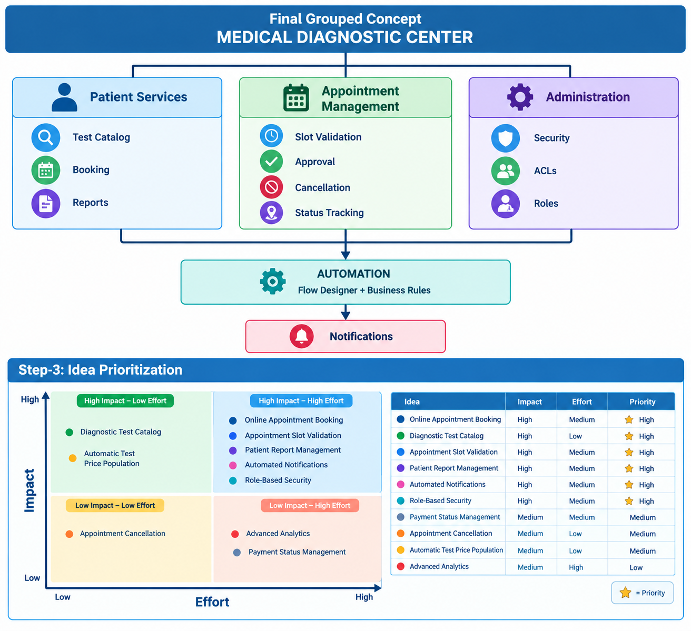
Final Prioritized Solution
Based on business impact, feasibility, and implementation effort, the team prioritized:
- Diagnostic Test Catalog
- Online Appointment Booking
- Appointment Slot Validation
- Patient Report Management
- Automated Notifications
- Role-Based Access Control
- Payment Management

